**GSLC 5 Compilation Techniques**

Kelompok 6

* Imanuel Alfa Ayors Wijata - 2440020562
* Alvin Kurnia Saputra - 2440022706
* Christhoper Standlie - 2440023910
* Jovianto Godjali - 2440028193
* Stevanus - 2440020865

Desain DFA dari:

(1) The set of strings over alphabet {a, b} that begin with **abb**

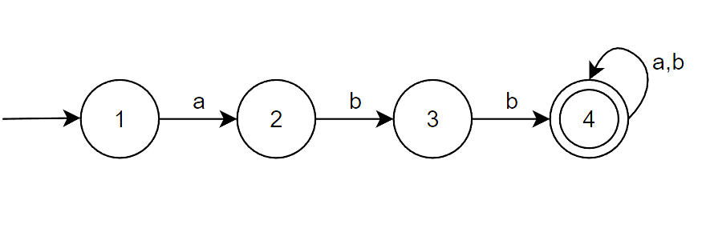

(2) The set of strings over alphabet {0, 1} with **011** as a substring

